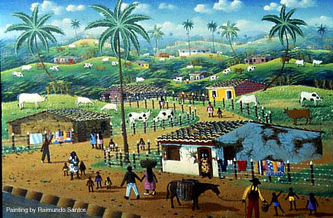

O Pelourinho! Popular Art from the Historic Heart of Brazil

EXHIBITION FACT SHEET

ORGANIZED BY: CON/VIDA – Popular Arts of the Americas
Co-Directors: Barbara Cervenka, O.P., and Marion Jackson, Ph.D.,

DESCRIPTION: The Pelourinho, the historic square at the heart of the old city of Salvador, the first capital of Brazil, is the center of a remarkable renewal of art and culture. Once a place used to auction African captives and punish rebellious slaves, the Pelhourinho has become the center of a resurgence of Afro-Brazilian culture and identity. Declared a World Heritage Site by UNESCO for its remarkable 17th and 18th century architecture, its once dilapidated buildings now are home to cultural groups who reclaim their African heritage through music, drum and dance. Small museums in the Pelourinho exhibit the religious art of the past and celebrate the folk traditions of the present. Painters and carvers create and sell work to tourists and collectors from small ateliers and informal galleries. The identification of so many groups with the Pelhourinho has transformed an area once associated with slavery into a thriving center of culture, an area only recently restored to its original brilliance and color. The spirituality of Candomblé and Catholicism form the backdrop of the cultural life and imagery of the Pelourinho, and the art that emerges combines African tradition with Brazilian history and popular culture. The exhibition features work by artists of the Pelourinho and the nearby town of Cachoeira who celebrate the history, experience and traditions of this rich area of the northeast of Brazil.

CONTENTS: Seventy paintings of varying sizes, framed and ready to hang; fifteen carved wood sculptures and wall plaques, fourteen iron ferramentas, mixed media truck, fabric banners; photographic panels of Salvador, the artists and Candomblé; and other documentary materials, including maps, introductions and explanatory labels. An illustrated interpretive exhibition brochure is available. Fifty exhibition brochures will be provided with the exhibition rental fee; additional copies available at $1.00 per copy.

REQUIREMENTS: Approximately 400 running feet of wall space, pedestals for sculptures and ferramentas.

SUPPORTED BY: Research leading to this exhibition has been supported by the following:
Social Science and Humanities Research Council of Canada
Adrian Dominican Sisters, Adrian, Michigan
Ministry of Culture and Tourism, Bahia, Brazil
Carleton University, Ottawa, Canada
Siena Heights University, Adrian, Michigan
Wayne State University, Detroit, Michigan;
University of Michigan, Ann Arbor, Michigan

TERMS: Rental: $3000 U.S. for eight weeks, $1000 for each additional month plus shipping and insurance. This exhibition travels in 13 wood crates weighing approximately 1200 lbs. total. Insurance value: $100,000 U.S.

EXHIBITION SCHEDULE: Siena Heights University, Adrian, MI – January 1997
Milwaukee Institute of Art and Design, Milwaukee, WI – July 1997
Wayne State University, Detroit, MI – Oct.-Nov. 1997
Fowler Museum, UCLA, Los Angeles, CA – Mar- May, 1998
Thames Art Gallery, Chatham, Ontario, Canada – July-Sept. 1998
Dennos Museum Center, Traverse City, MI – Dec. 1998-Feb. 1999
Florida A&M University, Talahassee, FL – Nov. 1999
Eastern Illinois University, Charleston, IL – Jan.-Feb. 2000
Canadian Museum of Civilization, Ottawa, Ontario – Feb.-Sept. 2001

CONTACT:
Con/Vida – Popular Arts of the Americas
440 Burroughs, Suite 365
Detroit, MI 48202 U.S.A.
Tel: 313-405-6443
Website: www.convida.org

Barbara Cervenka – bcervenk@comcast.net
Marion Jackson – mjackson@wayne.edu

